How to access your Leadership Toolkit from your mobile device

We host the Leadership Toolkit on a platform called SumTotal/CPP Learning. Although it supports mobile devices, not all training activities are optimized for mobile devices. For best results, please complete your training on a laptop, desktop, or tablet device.

1. Download the SumTotal Mobile App from the [Google Play](https://play.google.com/store/apps/details?id=com.sumtotal.mobileapp&hl=en_US&gl=US) or [Apple Store](https://apps.apple.com/us/app/sumtotal-mobile/id1169347043) and click Install
2. Open the SumTotal Mobile App
3. The first screen is the SumTotal welcome screen. It asks for the hostname. Please enter in the text box, “csu.sumtotal.host” and tap “NEXT”  
   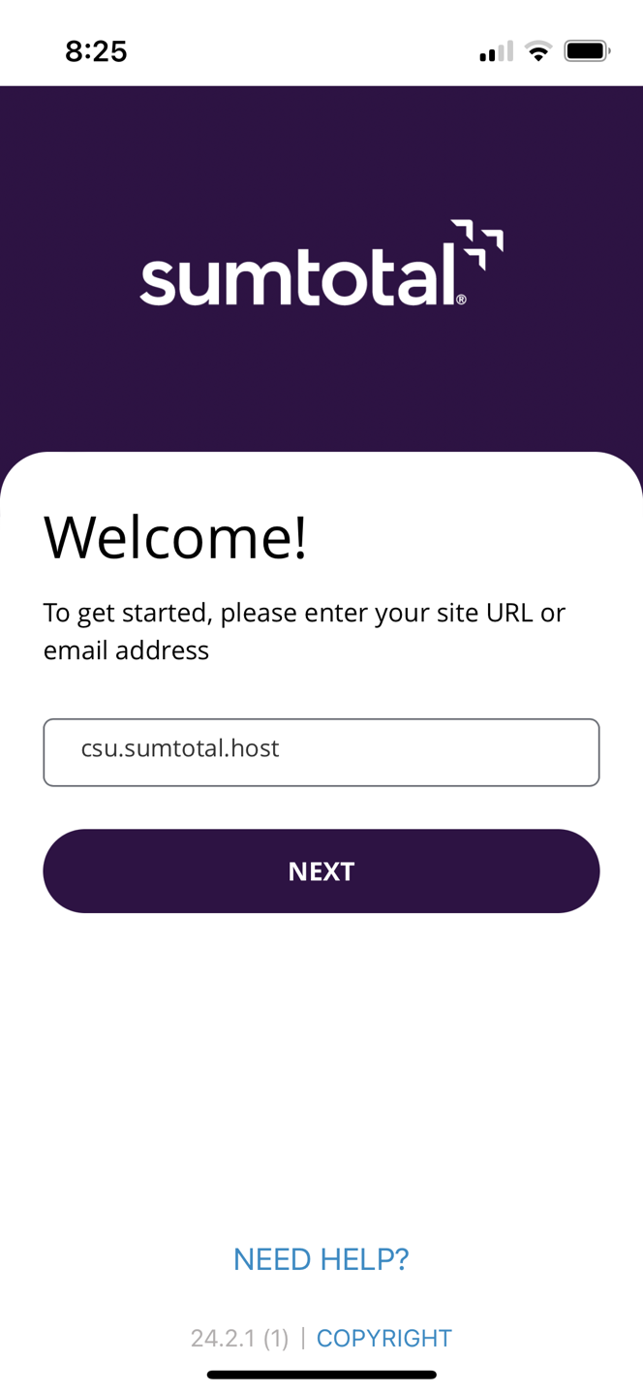
4. A login window will pop up, and you will be shown the Cal State University Single Sign-on Page. Select “Pomona” from the list. And then tap “Login” button   
   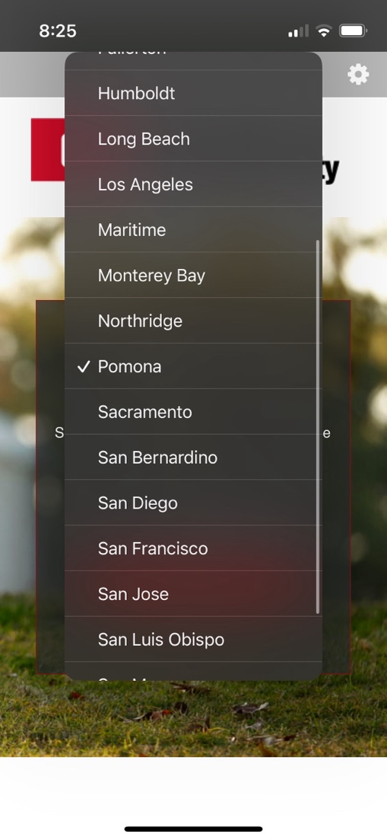
5. The login dialog will now change to the CPP login page. Please login and verify with Duo.
6. If this is your first time logging into SumTotal via mobile device, you will be asked to establish a 4-digit PIN number. This allows you to replay sessions without having an internet connection. Remember to click “Remember my Username” and tap “DONE”   
   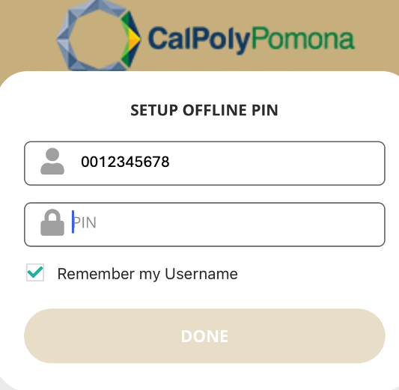
7. You should now be on the home screen of SumTotal. If you have previously unfinished sessions, they will be listed under “Resume Learning”  
   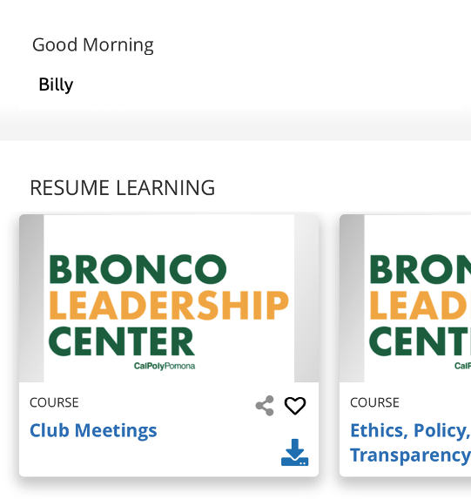
8. If there is nothing under “Resume Learning” at the bottom of the app, tap the “Courses” button  
   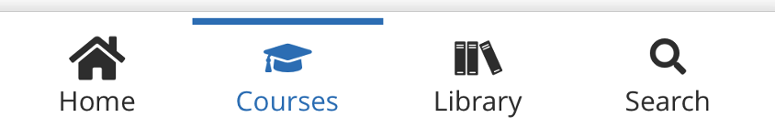
9. Under the courses header, tap “Assigned”  
   
10. Select any of the trainings assigned to you to begin your sessions.   
    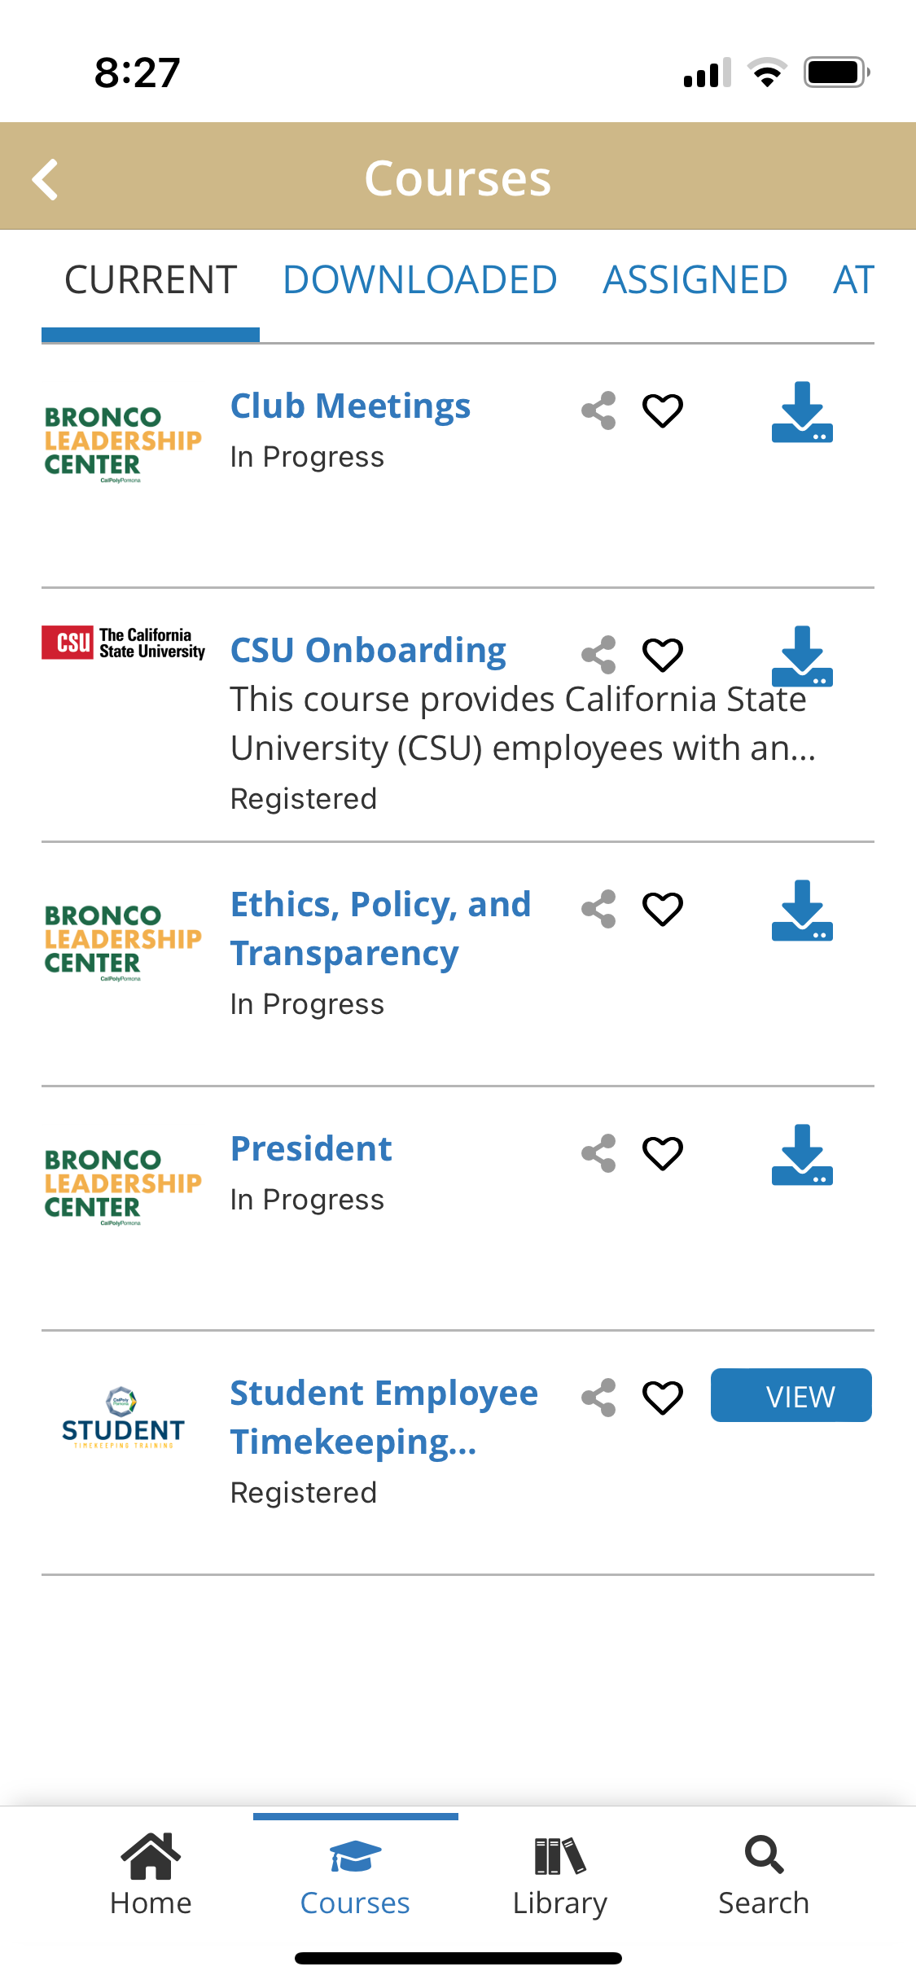
11. The description page opens. Tap the “Play” icon at the top, or tap “Start” button on the right of the screen.  
    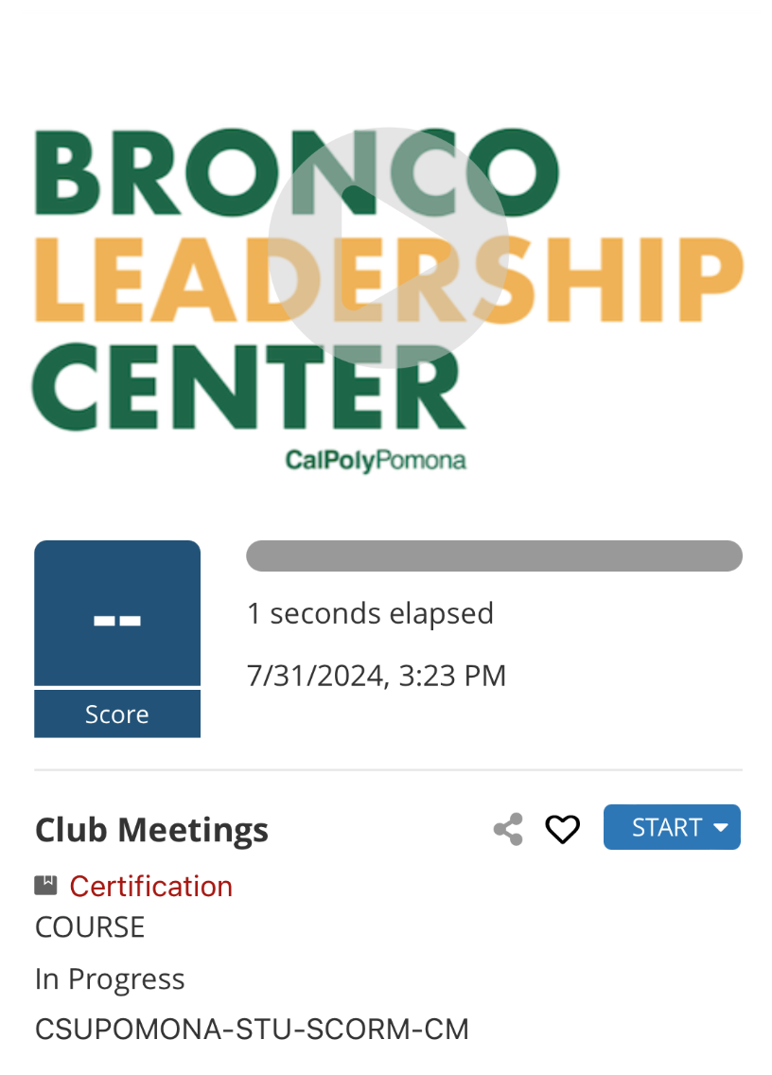
12. The app will ask you how you wish to review this session. Tap the “Start Online” button.  
      
    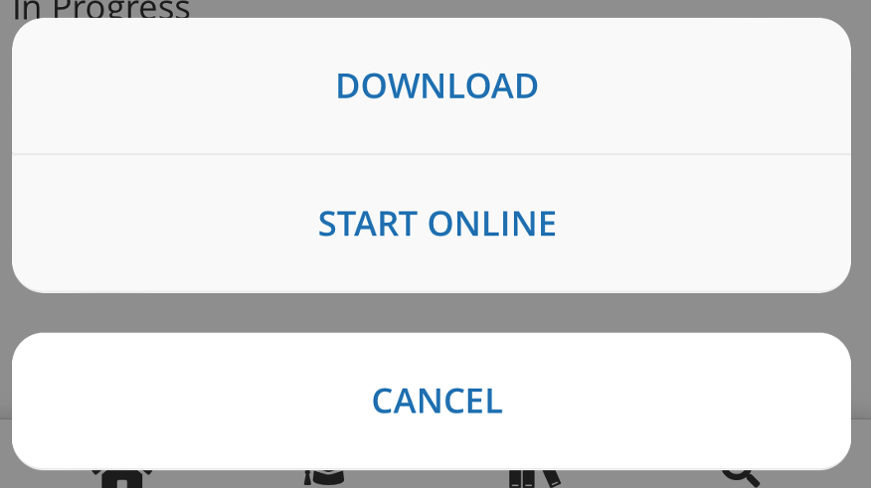
13. When you have completed the quiz and the session is over, tap the “Done” button on the bottom left of your screen.  
    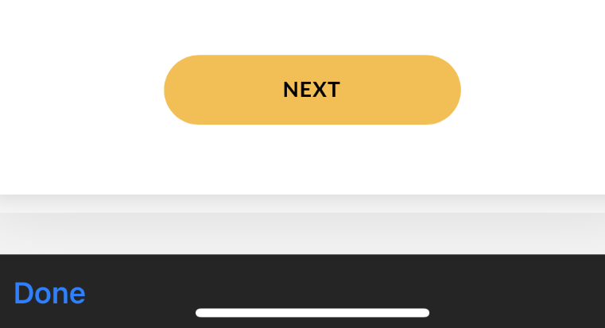
14. After you click Done, If you have completed the course, the course description now has your quiz score and should contain the word “Completed”  
    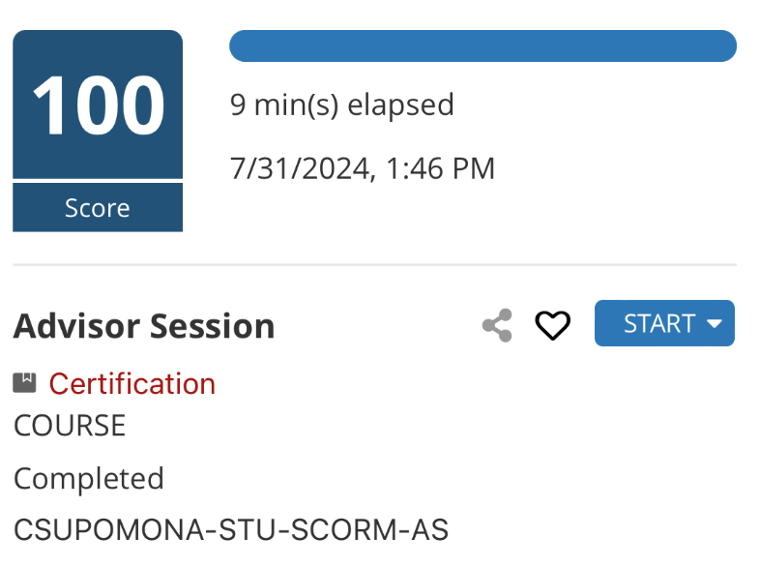
15. Ensure you complete all “Assigned” sessions.